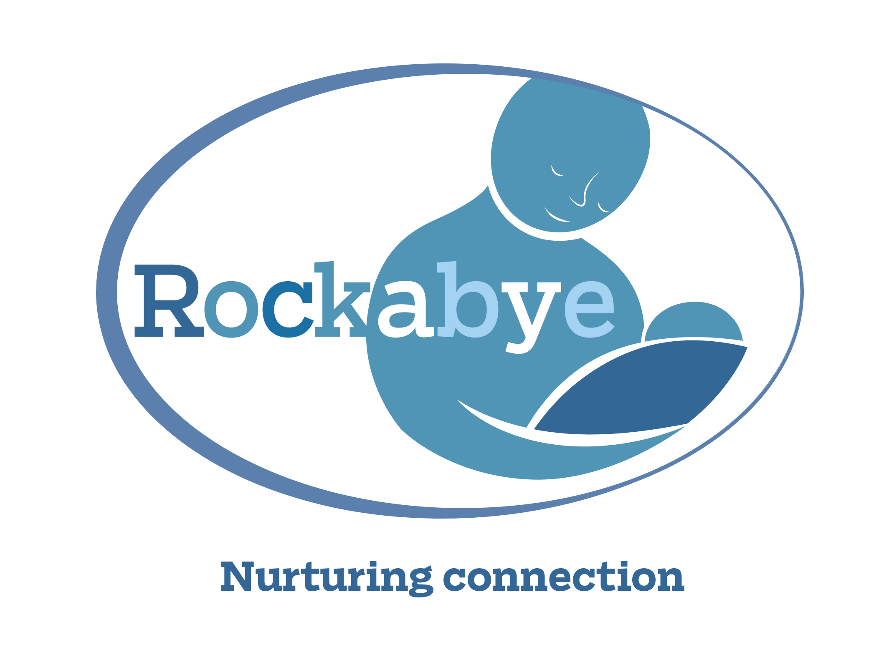
Rockabye Privacy Notice
Rockabye (Parent-Infant Support) CIC
www.rockabye.org.uk

Your Personal Information:
Rockabye is committed to protecting your privacy and security and will only collect, process and store your personal information in accordance with data protection laws. Personal information is information from which an individual’s identity can be ascertained. Rockabye (Parent-Infant Support) CIC is a data controller registered with the Information Commissioner’s Office (www.ico.org.uk). Our reference number is ZA631555.

The information we hold about you:
When we run groups in partnership with family support workers in children’s centres, we follow their Data Protection Policies. All notes are kept in the children’s centres.

When we run groups independently (usually within children’s centres but without the input of their staff), we keep personal data in a locked cabinet in the house of either group leaders or Rockabye Directors.

We might contact you by email and mobile telephone. Access to emails is password-protected. For the duration of the group, your phone number will be stored with your initials in the facilitator’s phone. This information will be deleted once the group is finished.
The personal data we take is as follows: your name and your baby’s name, address, email, date of birth, mobile number, next of kin’s name and number, any other mental health or health professionals involved in your care, and details of the reasons you are coming to Rockabye. These details are kept in a locked filing cabinet or in a password protected document on Rockabye’s computer system.

Rockabye receives personal data from parents themselves or from the professional referring families to us. This might be on a referral form sent through the post, or via a telephone conversation or email. Notes from the telephone conversation or email are added to your file and emails are subsequently deleted. Your file including your referral form is kept in a locked filing cabinet as stated above.

If a text or email contains information relevant to your case, a paper copy will be made of the message, and this will be added to your file, which will then be stored in the locked cabinet. The electronic text or email will then be deleted.

We keep your file securely until your child’s 25th birthday.

The Purpose of Collecting your Personal Information
We hold your contact details to let you know about practical details of group meetings, to contact you between sessions if we are concerned for you or your baby, and for the purposes of safeguarding.

We take notes about each family every week following the group to enable us to tailor our support for that family and to monitor whether there are any safeguarding concerns, in which case we follow our safeguarding policy.

Note-taking is also necessary for funder reports and monitoring the effectiveness of our work. All reporting and monitoring information is anonymised.

The lawful basis of our data processing:
We rely upon the lawful basis of legitimate interests to collect the personal information we hold about you in accordance with data protection legislation. ‘Legitimate interests’ means that we need to take notes in order to be able to carry out our work safely, effectively and responsibly.

Rockabye adheres to UK information-sharing guidance regarding any reported suspicions, concerns, disclosures or allegations and records any actions taken in conjunction with other professionals working with the family. Information-sharing will always be conducted on a strictly limited, need to know basis with, for example, your Health Visitor, Midwife, Mental Health Worker, Perinatal Mental Health Team professional or GP.

Your rights:
You have the right to request to see your notes. You will be given a copy of them within 30 days of your request. For further information please contact information@rockabye.org.uk requesting Rockabye’s GDPR policies.

If you have any concerns regarding this policy, or would like to make a complaint, please contact information@rockabye.org.uk requesting our complaints policy. You can also contact the ICO here: https://ico.org.uk/make-a-complaint/.

Updated:
7/10/25 Jennie Macdiarmid, Co-Director, Rockabye

